Mask 1: frontal polar (semantic > action)

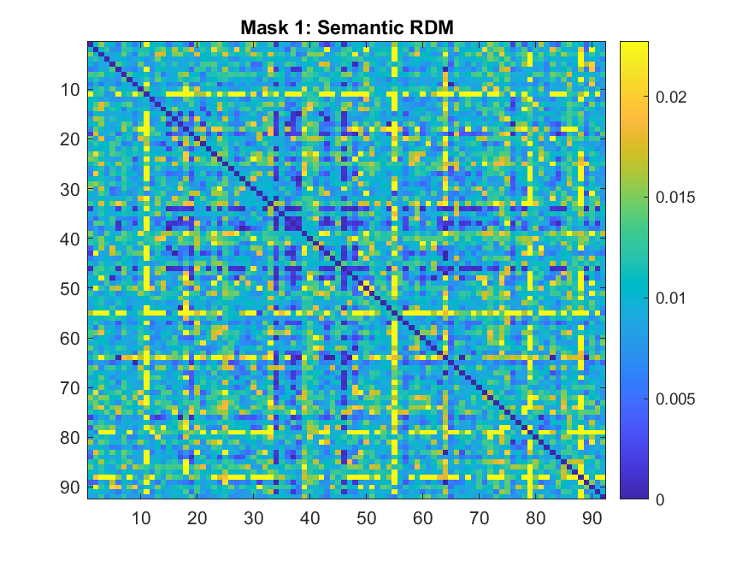

Mask 2: left anterior temporal lobe (semantic > action)

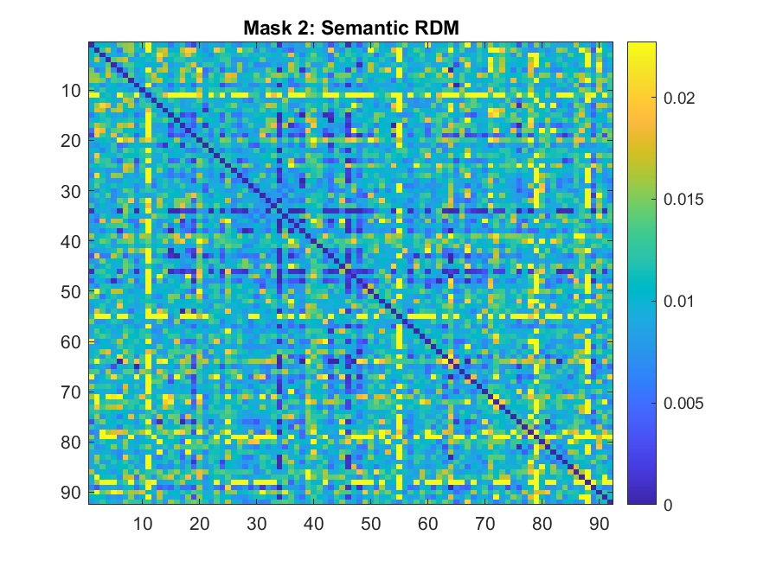

Mask 3: left fusiform gyrus (all stimuli)

Mask 4: left lateral occipital cortex (action > semantic)

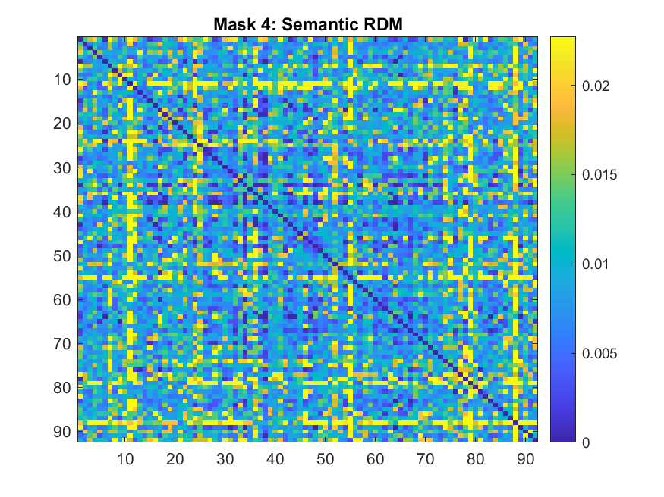

Mask 5: left lateral occipital cortex (all stimuli)

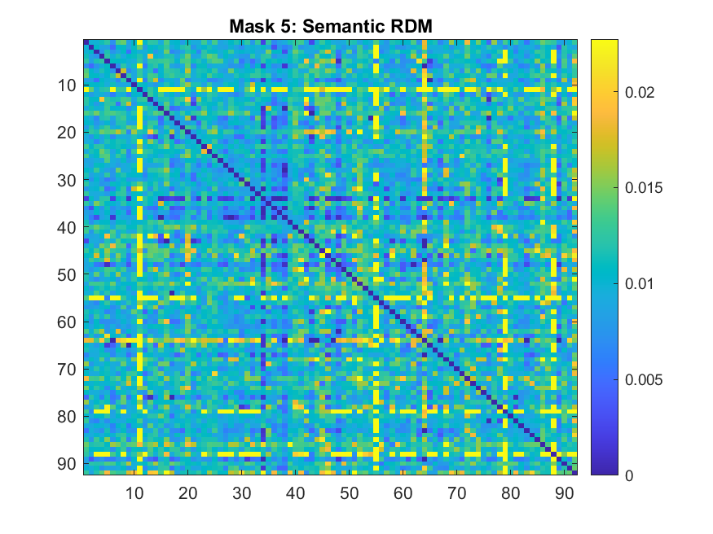

Mask 6: left parietal (action > semantic)

Mask 7: left posterior occipital visual cortex (all stimuli)

Mask 8: left pre-motor cortex (action > semantic)

Mask 9: posterior cirgulate gyrus (semantic > action)

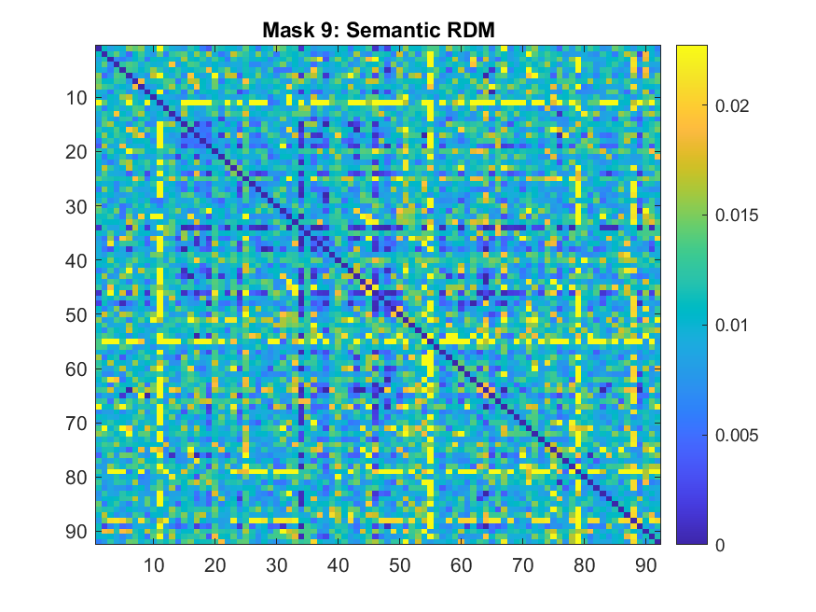

Mask 10: right cerebellum (action > semantic)

Mask 11: right fusiform gyrus (all stimuli)

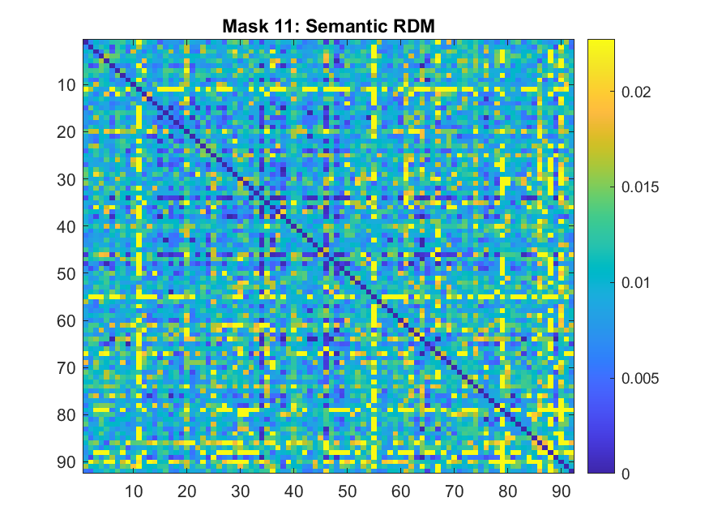

Mask 12: right lateral occipital cortex (all stimuli)

Mask 13: right parietal (action > semantic)

Mask 14: right posterior insula (semantic > action)

Mask 15: right superior frontal (semantic > action)

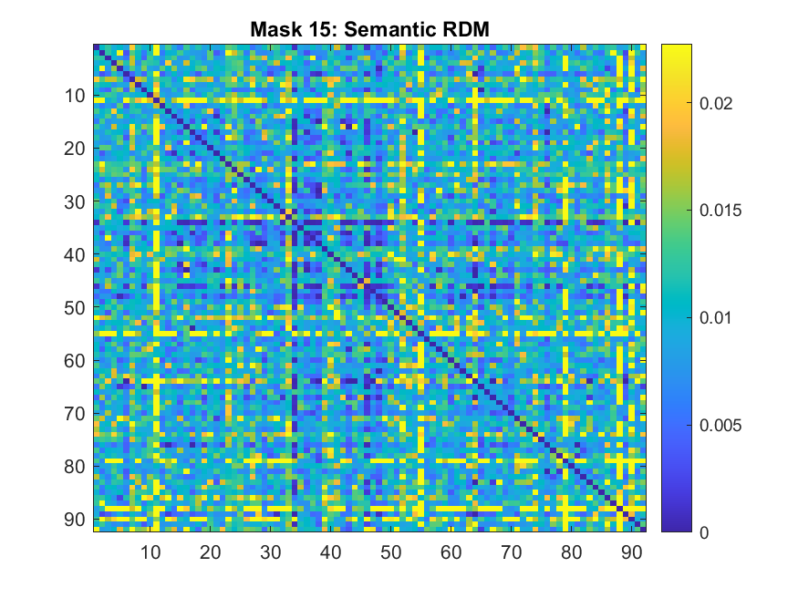

Behaviour RDMs

